**STEPS**

1. Open Visual C++ and click the New item in the File menu and a new dialog box is opened
2. Now select “MFC AppWizard (exe)” entry
3. Give the new Project name in the Project name box and click OK. Clicking OK will start the Visual C++ AppWizard

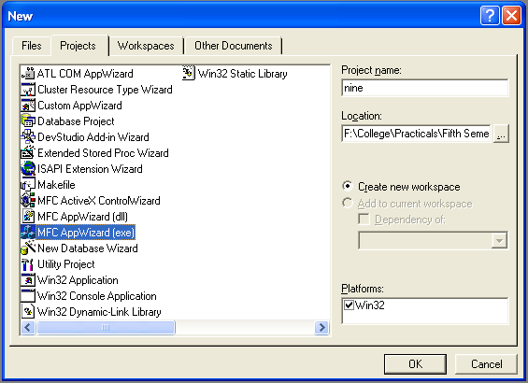

1. We will accept all defaults except one- by default, AppWizard creates Multiple Documents program and we will change so that it creates a Single Document program

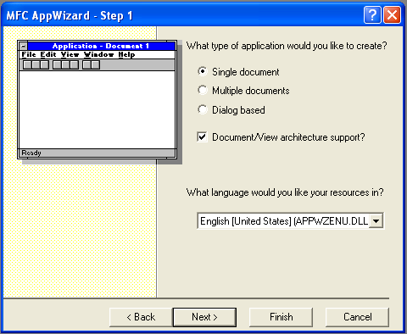

1. The AppWizard is asking for what database we want in our program; we will do “None” option selected. Keep pressing next until project information box is opened.
2. Click on the File menu option and a new dialog box is opened
3. Select the Resource Template File entry and give the file name in File name box

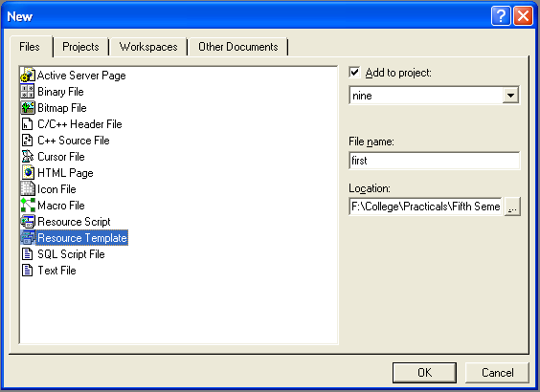

1. Click the Resource tab and select the “IDR_MAINFRAME” from the Menu folder. A window will appear in the work area. Insert our own menu and insert sub item into it. Example: we create “My Menu” as our menu and “Print Welcome” as its sub item

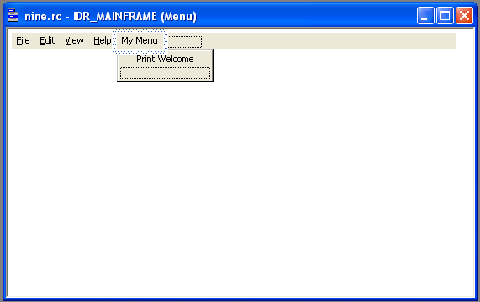

1. For connecting menu item to code, open class wizard and change class name to CNineView, from object id to “ID_MYMENU_PRINTWELCOME” ad double click on Command item from message list box. Double click the “OnFilePrintWelcome” method created
2. Open file menu tab and open ninedoc.h file from header files folder:

class CNineDoc : public CDocument

{

.

.

.

.

virtual ~CNineDoc();

* CString StringData;

.

.

.

.

}

1. Open ninedoc.cpp from source files folder:

CNineDoc::CNineDoc()

{

// TODO: add one-time construction code here

* StringData="";

}

1. Open the method “OnFilePrintWelcome()” which we created from class wizard from NineView.cpp:

void CNineView::OnMyMenuPrintWelcome()

{

// TODO: Add your command handler code here

* CNineDoc* pDoc=GetDocument();
* ASSERT_VALID(pDoc);
* pDoc->StringData="Welcome To My Menu!!!";
* Invalidate();

}

1. Finally we add the code to OnDraw() method to display the text in the StringData object:

void CNineView::OnDraw(CDC* pDC)

{

CNineDoc* pDoc = GetDocument();

ASSERT_VALID(pDoc);

* pDC->TextOut(0,0,pDoc->StringData);

// TODO: add draw code for native data here

}

1. Now run the program by build Nine.exe and Execute Nine.exe item in the Build menu and type some text into it

**OUTPUT**

